

**Cloud Computing Architecture Lab**

**Name:** Pratham Kandari

**Sap Id:** 500097663

**Batch:** 7

**Experiment- 13**

**Create an instance on GCP**

1. Create an instance on GCP via console, cloud shell and gcloud cli:

**(i).**Linux Instance

**(ii).**Windows Instance

**(i)Linux Instance**

Step 1) Go to GCP Console and click on new vm

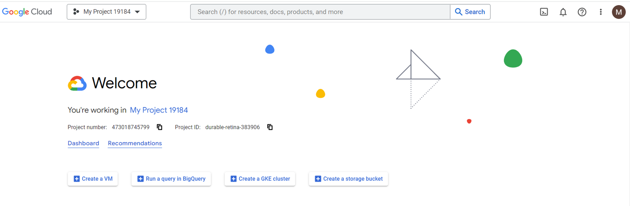

Step 2) Provide appropriate configuration for a Linux machine & create and leave the rest as default.

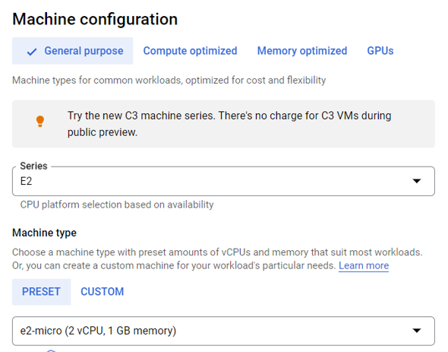

Step 3) Select the operating system.

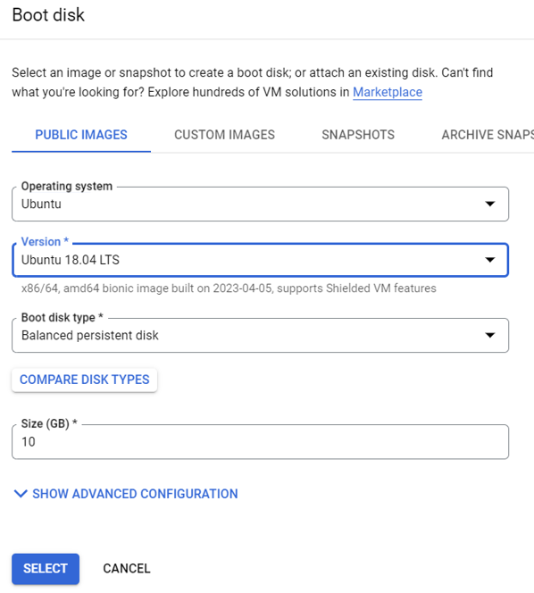

Step 4) Select both firewall.

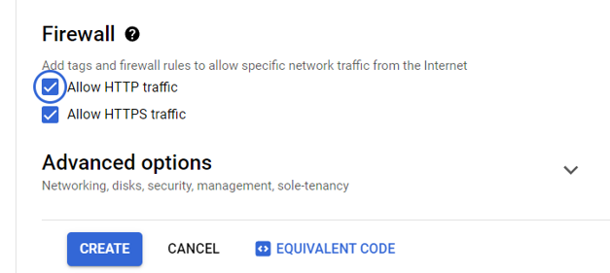

Step 5) In the instances catalogue, select the instance & connect via SSH.

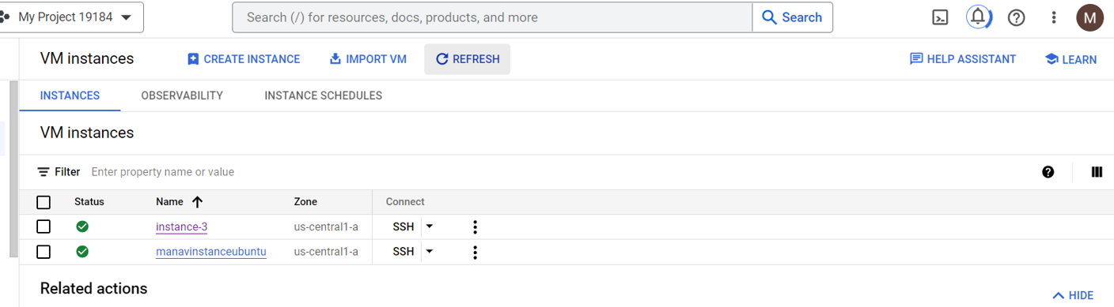

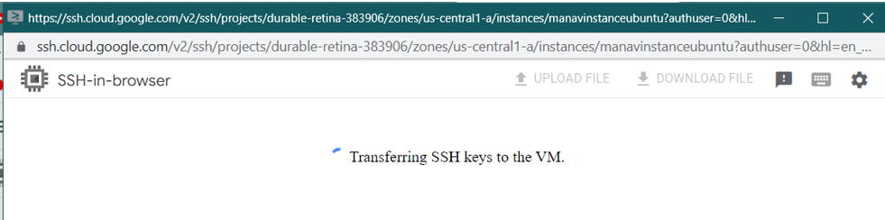

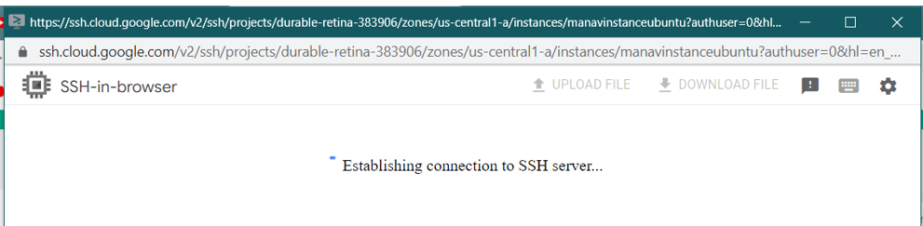

Step 6) Connected through SSH.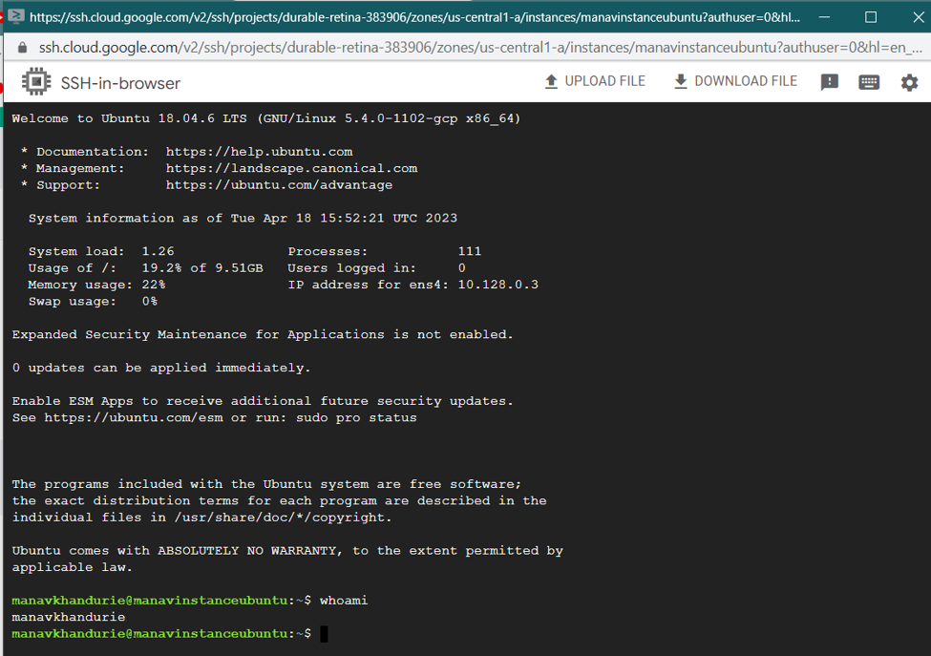

Step 7) To connect via cloud shell, go to instance-> view gcloud command.

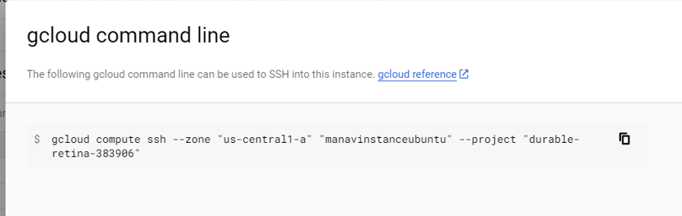

Step 8) Open cloud shell in console(present @ top right of the navbar).

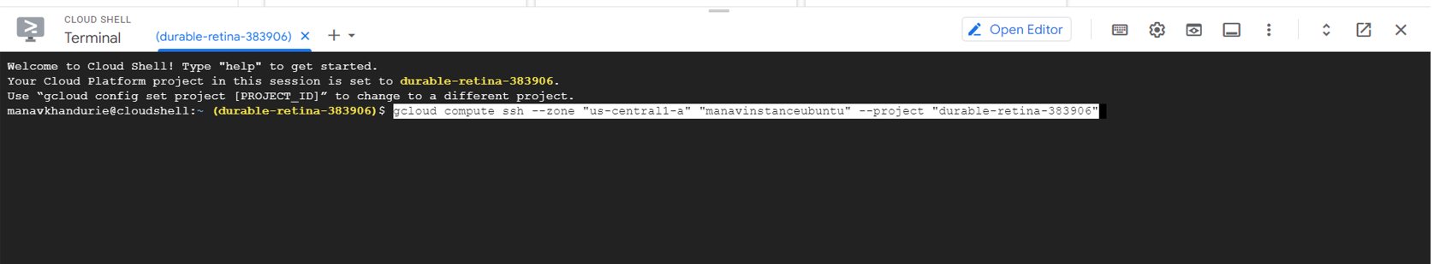

Step 9) Download & run the gcloud cli and run it.

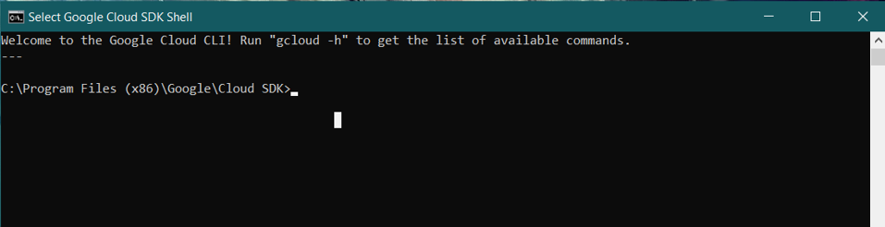

Step 10) Use the command to initialize

gcloud init

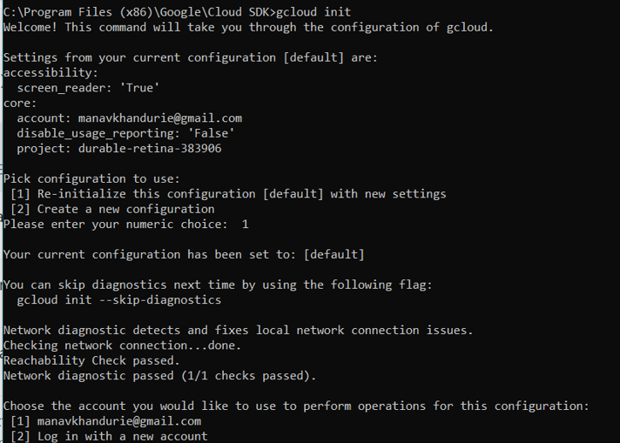

Step 11 ) Use the google account linked with gcp and select the project

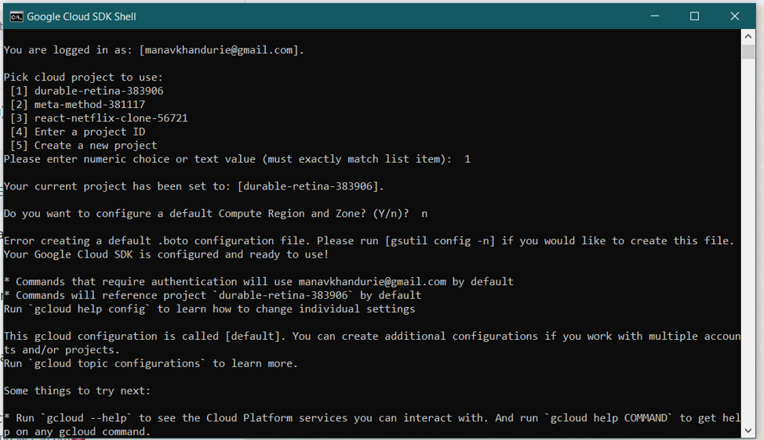

Step 12) Find a equivalent code for creating the instance through console

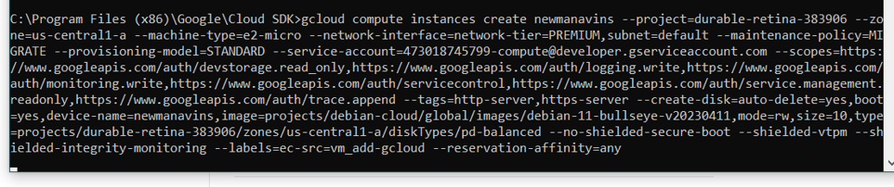

Step 13) paste the code in command line

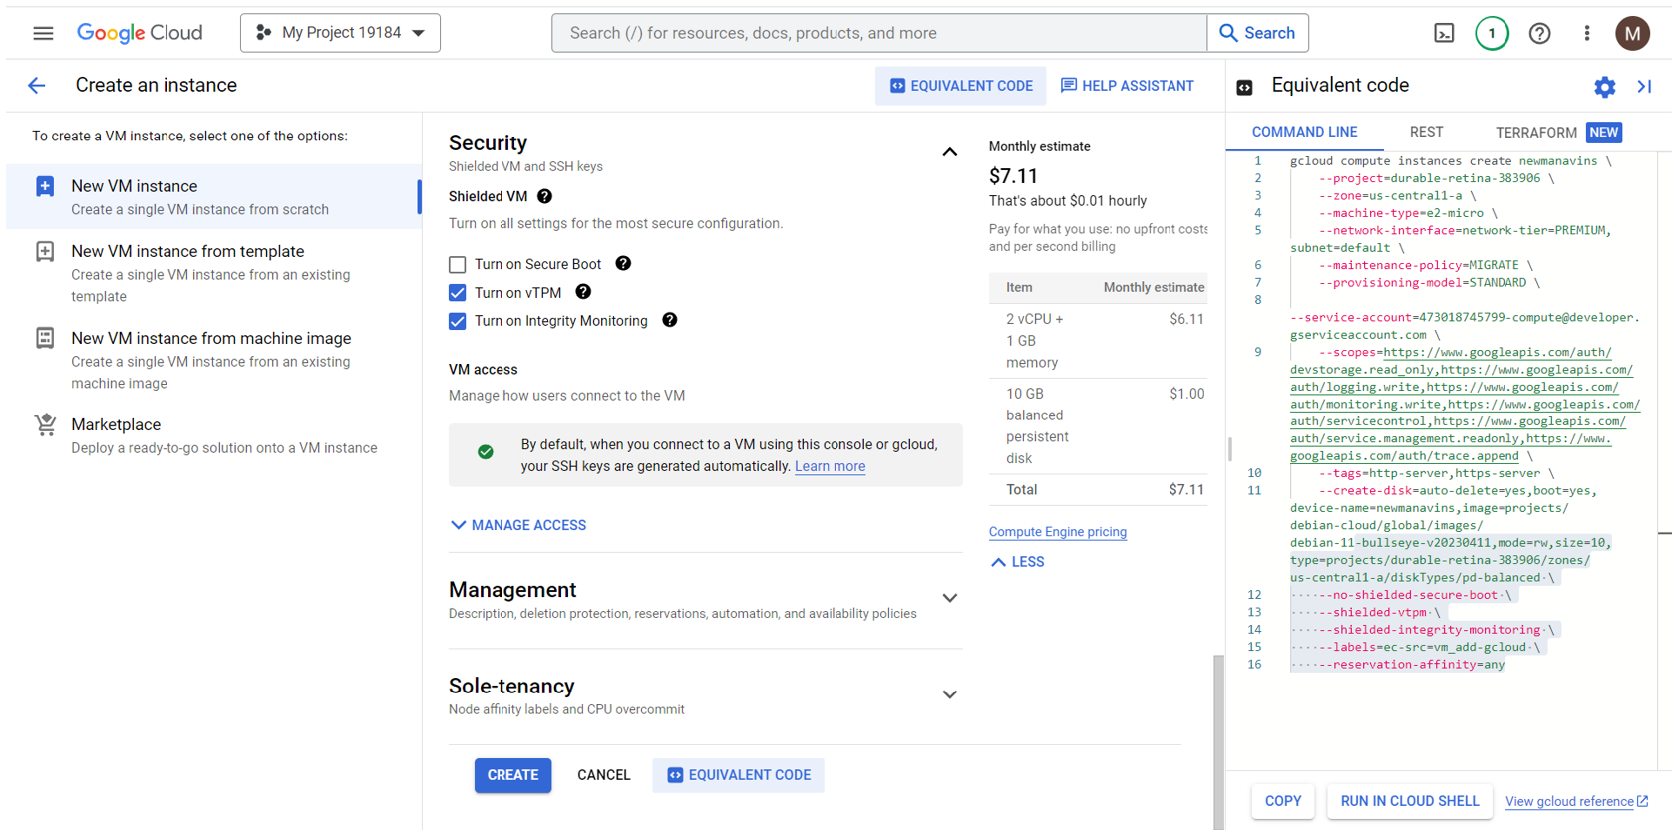

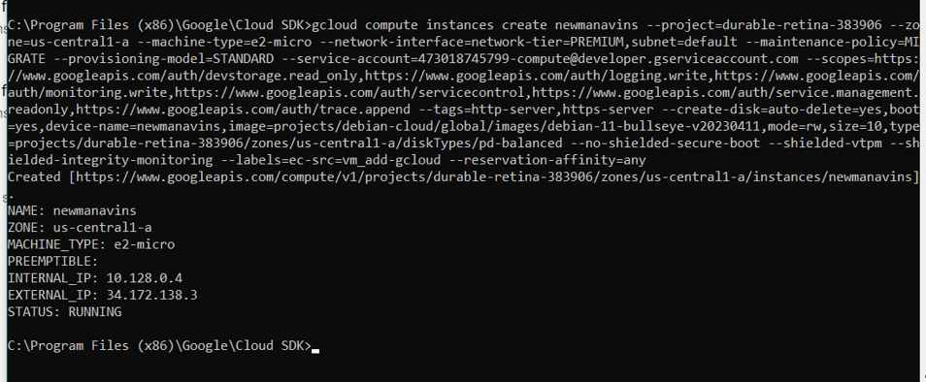

Step 14) Copy the gcloud command to connect

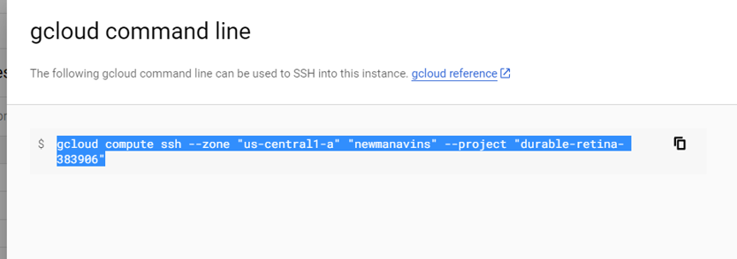

Step 15) Paste the command in the gcloud cli and press enter to connect

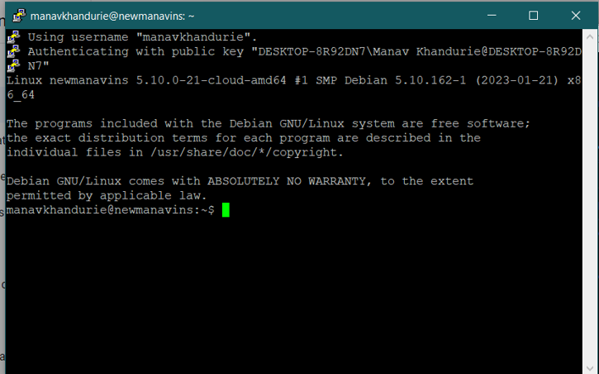

**(ii)Window**

Step 1) Go to Console & click on create VM & assign appropriate configurations

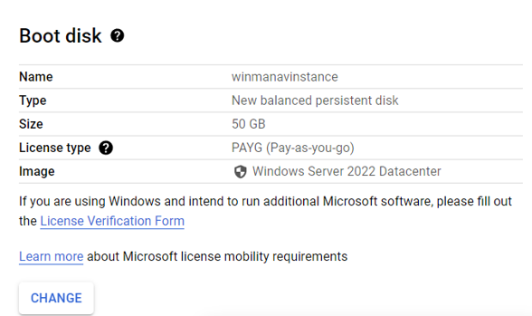

Step 2) Select the firewall

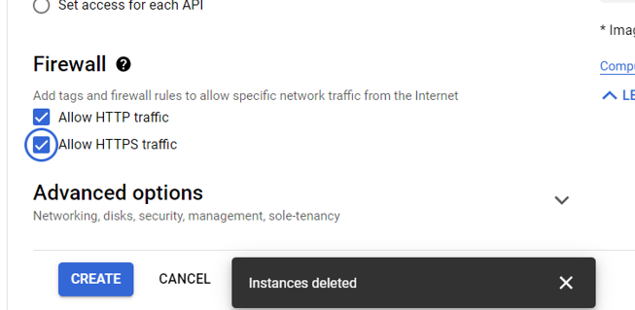

Step 3) Go to instance-> set Windows password & set a new password

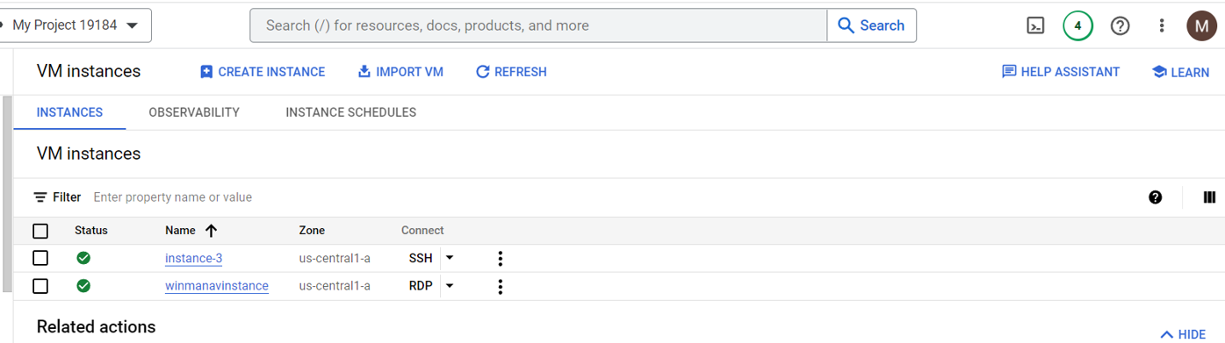

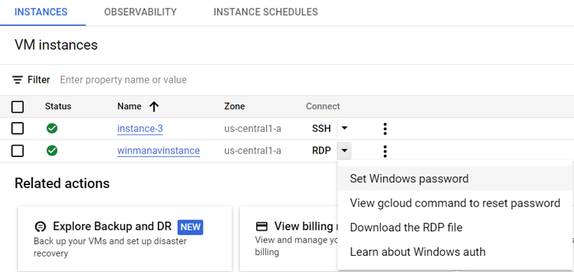

Step 4) Set new password

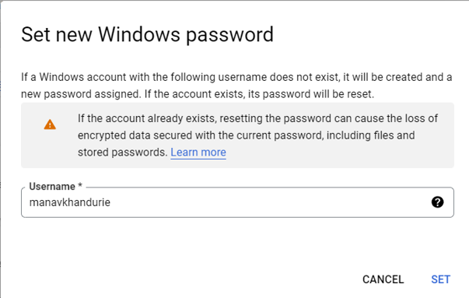

Step 5) Copy the password for login in remote desktop 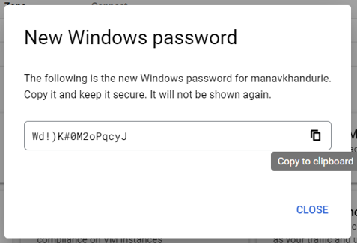

Step 6) Download and open RDP file

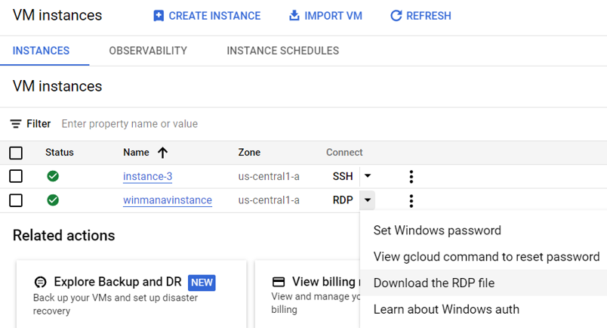

Step 7) open the window remote desktop

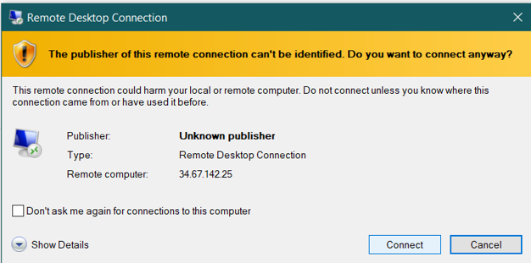

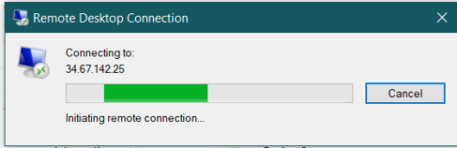

Step 8) Your remote desktop is opened

